Invitation

8th WoodWisdom-Net Research Programme Seminar
Tuesday 4th & Wednesday 5th of April, 2017
Royal Botanic Garden, Edinburgh, Scotland

Dear Friends and Partners,

We are pleased to invite you to attend the 8th WoodWisdom-Net Research Programme Seminar on 4th and 5th of April 2017 at the Royal Botanic Garden Edinburgh, Scotland.
This public final seminar of the 4th trans-national WoodWisdom-Net Joint Call (23 projects) will bring together researchers and stakeholders from industry, academia and policy-making organisations in the forest-based sector. The call was launched in 2013 with support from the European Commission through the 7th Framework Programme.
The objectives of the seminar will be to discuss the final results from the projects, to facilitate information exchange and networking between the projects and their stakeholders and to gain feedback and ideas for the further development of the WoodWisdom-Net Research Programme.
There will also be a specific network opportunity for WW-Net projects and stakeholders to meet with key UK based researchers and companies interested in wood fibre as a feedstock for biotechnology and construction.
WoodWisdom-Net, Forestry Commission & Forestry Commission Scotland as event organisers and hosts look forward to welcoming you to Scotland.

Programme

(Preliminary)

Tuesday, 4th of April
Day 1 | Moderator: Roger Coppock, Forestry Commission, Head of Corporate & Forestry Support
08:45-09:30 | Registration
09:30-09:40 | Welcome tbc
09:40-10:50 | Session 1: Introduction to forestry in Scotland (15 mins each):  - Scotland’s Forest Resource http://www.forestryscotland.com/  - Industrial Biotechnology Innovation Centre https://www.ibioic.com/  - Construction Scotland Innovation Centre http://www.cs-ic.org/  - Forest Research http://www.forestry.gov.uk/forestresearch  Questions (10 mins)
10:50-11:15 | Coffee and networking
11:15-12:20 | Session 2: Project summaries (10 mins each):  - (FastForests). Impact of faster growing forests on raw material properties with conderation of the potential effects of a changing climate on species choice.  - (VARMA). Value added by optimal wood raw material allocation & processing.  - (W3B Wood Believe). What we Wood Believe? Societal perceptions of the forest-based sector and it’s products towards a sustainable society.  - (TunableFilms). Tunable lignocellulose-based responsive films.  - (Lignohtl). Liquid fuels from lignin by hydrothermal liquefaction and deoxygenation.  Questions (15 mins)
12:20-13:45 | Lunch and networking
13:45-14:25 | Session 3: Project summaries (10 mins each):  - (Aerowood). Wood based aerogels for diverse applications especially in fields of packaging and biomedicine.  - (Pshapes). Polysaccharide bio-shapes;functional nano- and microsized particles for various value chains.  - (Compac). Plasticized lignocellulose composites for packaging materials.  Questions (10 mins)
14:25-15:20 | Session 4: Projects summaries (10 mins each):  - (Cosepa). Controlled seperation and conversion processes for wood hemicellulose.  - (Hemicell). Wood based chemicals, in particular chemical modified hemicellulose, used as functional additives to enhance the material properties of cellululose esters.  - (Pronanocell). Processes for nanocellulose composite manufacturing.  - (ReWoBioRef). Mobilisation and utilisation of recycled wood for lignocellulosic biorefinery processes.  Questions (15 mins)
15:20-15:50 | Coffee and networking
15:50-16:30 | Session 5: Project summaries (10 mins each)  - (DuraTB). Durable Timber Bridges.  - (Creosub). New protection technology to substitute creosote for the protection of railway sleepers, timber bridges and utility poles.  - (Biocopol). Enhancing wood durability and physical properties through innovative bio-based sustainable treatments.  Questions (10 mins)
16:30-16:40 | Closing day one

Wednesday, 5th of April
Day 2 | Moderator: tbc
09:30-09:35 | Welcome and Introduction
09:35-10:30 | Session 1: Project summaries (10 mins each):  - (EU Hardwoods). European hardwoods for the building sector.  - (CaRewood). Cascading recovered wood as a source of clean and reliable secondary wood products for the European industry.  - (LeanWood). Innovative lean processes and cooperation models for planning, production and maintenance of urban timber buildings.  - (Wood2New). Competitive wood based interior materials and systems for modern wood construction.  Questions (15 mins)
10:30-11:00 | Coffee and networking
11:00-12:00 | Session 2: Projects summaries (10 mins each)  - (HCLTP). Hybrid cross laminated timberplates to improve resource efficiency.  - (TallFacades). Tall Timber Facades – Identification of cost effective and resilient envelopes for wood constructions.  - (Silent Timber Build). Silent timber build for the European market. Calculation models for acoustics and vibration in wooden construction.  - (WoTim). Wood based thermal insulation materials.  Questions (15 mins)
12:00 -12:15 | Session 3: Vision and Roadmap for European Raw Materials in 2050 (speaker tbc)
12:15-12:45 | Session 4: Future activities of WoodWisdom-Net (ERA-NET Cofund on Innovative forest-based bioeconomy) and discussion (Mika Kallio)
12:45-13:05 | Summing up (Ilmari Absetz)
13:05- | Lunch and networking, then departure

Registration

Please complete the attached registration form and return it to Evelyn Hall (evelyn.hall@forestry.gsi.gov.uk) no later than the 22nd March 2017. Participation fees (as detailed below) should be paid by credit/debit card only. Once payment has been received a place will be reserved for you at the event. A receipt for payment will be sent to you under separate cover direct from our Finance Team.

All seminar participants, including the JC4 project co-ordinators, are required to pay a participation fee to cover expenses for meals, coffee and other light refreshments.

Day 1: Seminar - £40 (45€, excl. VAT)

Day 2: Seminar - £35 (40€, excl. VAT)

Travel information

Edinburgh Airport is 8 miles from Royal Botanic Garden (Inverleith Row/Arboretum Place, Edinburgh EH3 5LR). A frequent Airlink bus runs between the airport and the city centre. The service operates 24 hours a day, 7 days a week with buses every 10 minutes during the day. Journey time to City Centre is approximately 30 minutes.
The nearest railway station is Edinburgh Waverley, which is only 1.5 miles away and is connected to the Garden by Lothian Buses service No. 8.
The Royal Botanic Garden Edinburgh is situated off the A902, one mile north of the city centre, with entrances on Inverleith Row (East Gate) and Arboretum Place (West Gate and John Hope Gateway).

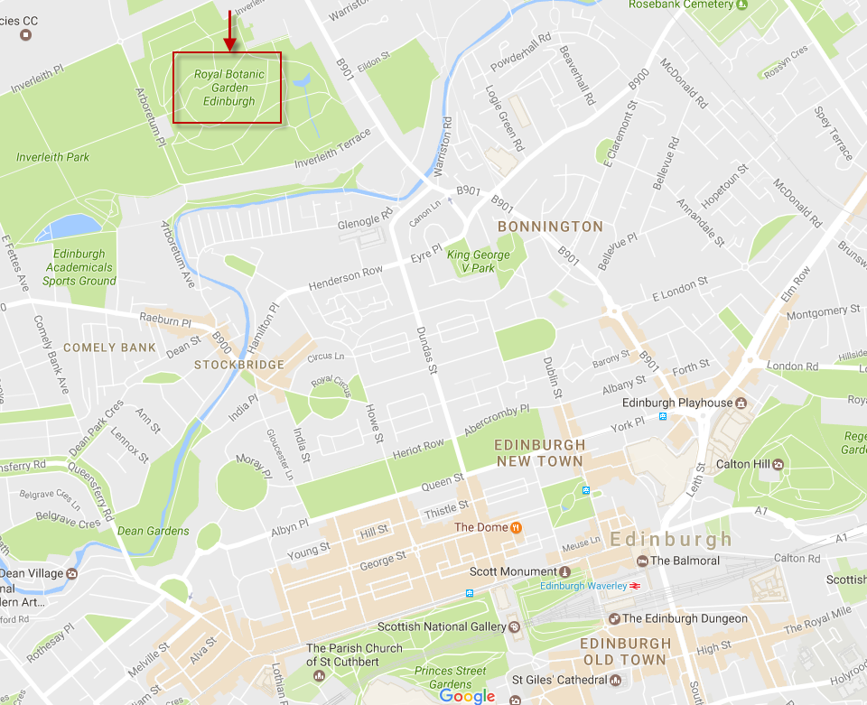

Accommodation

Participants are responsible for their own hotel bookings.

Contacts

Seminar Information

Andy Leitch
Andy.Leitch@forestry.gsi.gov.uk
+44 788 151 0171

Registration

Evelyn Hall
Evelyn.hall@forestry.gsi.gov.uk
+44 300 067 5901

WoodWisdom-Net Research Programme
Mika Kallio
mika.kallio@woodwisdom.net
+358 50 361 2694

For updated information on the seminar and the WoodWisdom-Net Research Programme, please visit: www.woodwisdom.net.

REGISTRATION FORM
SECTION ONE: DELEGATE DETAILS

Surname
Forenames
Title
Organisation
Address
 |  | Postcode
Telephone Number
Email Address
Special dietary requirements (e.g. vegetarian/gluten free)
Do you have any special needs that you wish us to be aware of? |  |  | Yes |  | No
If yes, please state
SECTION TWO: REGISTRATION FEES

Day 1 : Registration Fees - £40.00 (45€, excl. VAT)

Day 2 : Registration Fees - £35.00 (35€, excl. VAT)

Credit/Debit Card:

Card Type | Barclaycard /Mastercard /Debit Card (Please tick relevant card)
Card No. |  |  |  | Valid from
Issue No. (if paying by Debit Card) |  |  |  | Expiry Date
Card Verification Number*
Cardholder Name
Cardholder Signature

*Due to bank security regulations we require the three-digit Card Verification Number (CVN) on the back of your card. If you do not want to include your CVN on this form, please contact Evelyn Hall on +44 300 067 5901. Note that registrations paid by Credit/Debit Card will not be confirmed until the transaction has been authorised.
Evelyn Hall (evelyn.hall@forestry.gsi.gov.uk)
Events Coordinator, Forest Research, Northern Research Station, Roslin, Midlothian, EH25 9SY

